This template is used for all published/submission-ready published Case Report Forms (CRFs) (sample, blank annotated and patient CRFs)

Publishing QC Requestor Name:
Publishing QC Reviewer Name:
Type of CRFs: | Please indicate the CRF type here, e.g. Sample, Bank Annotated, Patient. Please change the text color to black and delete the instructions

Please include below a screen shot of document(s) QC reviewed: (Note: The screen shot should clearly include date/time stamp of folders/files, as appropriate, and include file path [or include file path separately]). If the screenshot is not possible, the main folder path should be included.

Instructions for Checklist Use:

- The Publishing QC Reviewer should include a check mark (X) in the “Y” column to indicate a finding is noted; a checkmark in the “N” column to indicate data has been verified and no revisions necessary; and a checkmark in the “N/A” column to indicate the item is not applicable for the document. Findings that require a revision should be further explained, if needed, in the ADDITIONAL DETAILS ON QC FINDINGS (IF NEEDED) section. Upon completion of the QC review, the QC Reviewer should include his/her full name and the date in the “QC Complete” portion of the template.

- The Publishing QC Requestor should review the findings, i.e. where a check mark (X) was included in the “Y” column. If the proposed change is implemented, the Publisher includes his/her full name and date in the “Publisher” section to confirm that the finding(s) has been addressed, otherwise includes a reason against to the finding(s) for not implementing it.

- The Publishing QC Reviewer should verify the changes and confirm that changes have been verified by including his/her full name and date in the “Changes Verified” portion of the “Completed” section of the template.

Item | Revision |  |  |  | Comments
 | Y |  | N | N/A
ALL CRFS – Sample, Blank Annotated, Patient
Document Level Verification
- PDF Version should be between 1.4-1.7 with Fast Web View “Yes”.
- All Fonts should be Embedded, if possible.
- Check the File Size
(should not exceed 100 MB for both US and ROW).
- Documents should not be Secured
- When Overall Page stamping is done, make sure they don’t overlap in the footer.
- Check if Page Size is set as per region.
(US submission - Letter and EU submission - A4).
- Pages oriented appropriately and Check for any Blank Pages
[If a blank page is intentionally left in the document
(per client confirmation), this page should be stamped as "Page is intentionally left blank"].
- PDF Document Title Fields (when required):
For specified projects, PDF Document Title Field is filled out correctly] (as a default, projects do not require the PDF Document Title Field).
When required:
- Sample CRF: 1612-Sample CRF.
- Blank Annotated CRF: Study xxx, Annotated CRF.
- Patient CRFs: crf, study 102, site 001, PID 102-001-112.
- Document properties are set to:
- Initial View: Bookmarks Panel and Page.
- Page Layout and Magnification set to Default.
- Window and User Interface Options should be unchecked.
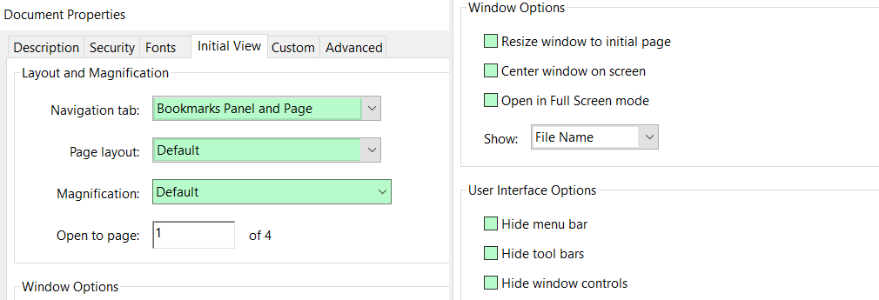
- Filenames are standard and consistent to meet client specifications:
- Sample CRF: studynum-1612-sample-crf.pdf.
- Blank Annotated CRF: blankcrf.pdf.
- Patient CRFs: Typically, this is siteid-pid.pdf, some clients require just pid.pdf (pid=Patient ID). If only patient ID is used, site folders may be required to avoid duplicate filenames.
File Name: Should not exceed 64 characters in length including the extension (All lower case and no special characters other than hyphen should be used in the file name).
Bookmark Standards
- All By Visit, Bookmarks need to be bookmarked.
- 100% QC need to be done.
- By Domain Bookmarks should be arranged in alphabetic order.
- 25% QC need to be done.
- Check that both “By Visit” and “By Domain” Bookmarks are set to navigate to first page of the visit (not to the cover page).
- Stand-alone bookmarks (such as Adverse Events, Study End, Signatures, etc.) are not part of By Visit or By Domain and stand-alone.
NOTE: Some Sample CRFs do not contain Visit information and By Domain bookmarks are acceptable. Some clients may require the Sample CRF to have both by Visit and By Domain and in this case, the Study Time and Events Schedule must be used to build the bookmarks and QC them.
- Bookmarks are collapsed to By Visit and By Domain level.
- Special Characters/Symbols should be captured accurately in the bookmark.
- Top bookmark exists as follows:
- Sample CRF: Study Number, Appendix 16.1.2 Sample CRF.
- Blank Annotated CRF: Study Number, Annotated CRF.
- Patient CRFs: Study Number, Site ID, Patient ID.
- Check all Bookmarks are set to Inherit Zoom Magnification are all Valid and have ‘NO’ in the Named Destination column.
Hyperlinking Standards
- Hypertext links appear to provide compliant navigation from DCFs to related CRF pages
- One-way linking – Link are created from DCF page to CRF Page
- Two-way linking - Link are created from Both DCF to CRF page and CRF to DCF pages
- Link Attributes must be applied as per the ICH Standards
- Electronic Page - Invisible Rectangle & Blue Link Text color
- Scanned Page - Visible Rectangle
- Web-links need to be deleted.
- Check all Links are set to Inherit Zoom Magnification are all Valid.

Completed: (signifying QC checklist was followed and findings documented or changes verified)

________________________________________  QC Complete Date  (Full name) (DD-Mmm-YYYY) | ______________________________________  Changes Verified Date  (Full name) (DD-Mmm-YYYY)
___________________________________________
Publishing QC Requestor Date
(Full name) (DD-Mmm-YYYY)

ADDITIONAL DETAILS ON QC FINDINGS (IF NEEDED)

Notes:
- Clearly indicate filename, folder path, and page number, as needed, so the Publishing QC Requestor can easily locate the finding.
- Only include information for files with QC findings; do not list files that need no changes.
- Include screen shots, where possible.

Additional Details | Publishing QC Requestor implemented | QC Verification

